MSWORD2000 SHEET6: INSERTING PICTURES, AUTOSHAPES, AND WORDART

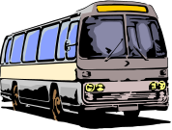

WORDART

WORDART
WORDART

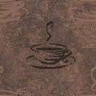



Inserting pictures from the categories Academic, plants, and transportation.

Drawing autoshapes.

WordArt…

Inserting pictures from a file. (c:\winnt\Coffee Bean.bmp)
Comp No:

